**A Course book on**

**Indian Traditional Knowledge**

***For B.Tech Students***

**18LEM109T**

**Department of English and Foreign Languages**

**SRM Institute of Science and Technology**

**Syllabus**

| **Course Learning Rationale (CLR):** | | | *The purpose of learning this course is to:* |  | **Learning** | | |  | **Program Learning Outcomes (PLO)** | | | | | | | | | | | | | | |
| --- | --- | --- | --- | --- | --- | --- | --- | --- | --- | --- | --- | --- | --- | --- | --- | --- | --- | --- | --- | --- | --- | --- | --- |
| **CLR-1 :** | *To introduce the learners to the early and traditional environmental friendly agricultural practices* | | |  | 1 | 2 | 3 |  | 1 | 2 | 3 | 4 | 5 | 6 | 7 | 8 | 9 | 10 | 11 | 12 | 13 | 14 | 15 |
| **CLR-2 :** | *To enable the students to recognize and appreciate the contribution of India to astronomical studies* | | |  | Level of Thinking (Bloom) | Expected Proficiency (%) | Expected Attainment (%) |  | Engineering Knowledge | Problem Analysis | Design & Development | Analysis, Design, Research | Modern Tool Usage | Society & Culture | Environment & Sustainability | Ethics | Individual & Team Work | Communication | Project Mgt. & Finance | Life Long Learning | PSO - 1 | PSO - 2 | PSO - 3 |
| **CLR-3 :** | *To draw the learner’s attention towards the holistic approach behind Indian system of medicine* | | |  |  |
| **CLR-4 :** | *To cultivate a sense of appreciation aboutancient Indian Engineering and Technology as diverse, culture and resource specific* | | |  |  |
| **CLR-5** | *To develop anunderstanding about the connection of daily life to the environment and a healthy lifestyle through a comparison of the linguistic phrases and sayings and analyzing them from today’s science* | | |  |  |
|  | |  | |  |  |
| **Course Learning Outcomes (CLO):** | | | *At the end of this course, learners will be* | |  |
| **CLO-1 :** | *equipped with an awareness of the ancient India’s eco consciousness andIndia’s contribution to astronomy and the beliefs associated with it* | | | |  |  |  |  | - | - | - | - | - | H | H | H | H | H | - | H | - | - | - |
| **CLO-2 :** | *able to appreciate the Indian aesthetic sensibility which is evidenced in the architectural monuments, economic life and religious worship* | | | |  |  |  |  | - | - | - | - | L | H | M | M | H | H | - | H | - | - | - |
| **CLO-3 :** | *able to understand how Indians have had a holistic approach towards human life integrating the body, mind and soul* | | | |  |  |  |  | - | - | - | - | - | H | H | H | H | H | - | H | - | - | - |

|  | | **Learning Unit / Module 1** | **Learning Unit / Module 2** | **Learning Unit / Module 3** | **Learning Unit / Module 4** | **Learning Unit / Module 5** |
| --- | --- | --- | --- | --- | --- | --- |
| **Duration (hour)** | | **3**  **AGRICULTURE** | **3**  **MATHEMATICS &ASTRONOMY** | **3**  **MEDICINE** | **3**  **ENGINEERING & TECHNOLOGY** | **3**  **CUSTOMS, SAYINGS AND LIFE TRUTHS** |
| **S-1** | **SLO-1** | Early agricultural settlements - Influencing Factors – locale and climate | Concepts of time and space - Knowledge of the Universe | **Introduction to the school of Ayurveda, Siddha and Naturopathy:** | Architecture – Temples, forts, palaces, houses and town planning | **Regionalmyths, beliefs,,and cultural practices** |
| **SLO-2** | **Locating the early agricultural settlements in the Indian map and indicating the timeline** | **Quiz based on the Indian concept of time and distance between the planets** | **Compare and Contrast of the methodologies, popular beliefs, myths and truths about medications** | **Group Discussions through examples from different historical periods and geographical locations** | Noting the idioms, proverbs in mother tongues connected to seasons and festivals |
| **S-2** | **SLO-1** | Crop cultivation - Community basedEnvironment friendly practices | Great astronomers and mathematicians of ancient India | Common features - Holistic Therapeutic Approach – Natural elements, individual constitution (Humours), and the balance recommended | Metallurgy – Coins, Traditional Indian Metal Carvings | Traditional Foods of India in accordance with the climate and availability of the resources |
| **SLO-2** | **Group presentations on the traditional agricultural practices in selected states** | **The respective contributions of Astronomers and Mathematicians** | **Understanding the rationale behind selected sample treatments provided or advised, Case Studies** | **Discussions on historical periods and their architectural influences** | Collecting old sayings in specific regions of India |
| **S-3** | **SLO-1** | **Ancient Indian Water management and irrigation methods** | The planetary system and Indian Astrology: Basic Facts | Yoga and its Universal Appeal | Textile technology – Region / Culture specific Fiber, Fabric and weaving | Translating Regional sayings into English |
| **SLO-2** | **A region based study of natural water resources and aquifers and types of irrigation** | Discussion on a few sample birth charts and predictions made | **Discussions on worldwide popularity of Yoga and meditation** | **Comparing the Temple Architecture of North and Southern Indian States** | Traditional sayings about Hygiene and practices pertaining to them |
| **Learning**  **Resources** | | 1. **Texts / Audios / Videos / Images** 2. **Texts / Audios / Videos / Images** | | | | |

|  | **Level of Thinking** | **Continuous Assessment** | | | **Final Examination (40%)** |
| --- | --- | --- | --- | --- | --- |
| **CA – 1 (20%)** | **CA – 2 (20%)** | **CA – 3 (20%) #** |
| **Level 1** | **Remember** | **40 %** | **30 %** | **30 %** | **30 %** |
| **Understand** |
| **Level 2** | **Apply** | **40 %** | **40 %** | **40 %** | **40 %** |
| **Analyze** |
| **Level 3** | **Evaluate** | **20 %** | **30 %** | **30 %** | **30 %** |
| **Create** |

TEXT BOOKS:

V. Sivaramakrishnan (Ed.), *Cultural Heritage of India-course material*, BharatiyaVidyaBhavan, Mumbai. 5th Edition, 2014.

Basham, A.L. ed.  *A Cultural History of India*. OUP, 1997.

REFERENCES:

Thapar, Romila. *Indian Cultures as Heritage*: *Contemporary Past*. Aleph Book Company, 2018.

GN Jha (Eng. Trans.), Ed. RN Jha, *Yoga-darshanam with VyasaBhashya*, VidyanidhiPrakashan, Delhi 2016.

**Evaluation Sheet**

**Name of the Student: Name of the Teacher:**

**Reg. No.: Branch:**

| **S.No** | **Date** | **Hour** | **Topic** |  |
| --- | --- | --- | --- | --- |
|  |  |  |  |  |
|  |  |  |  |  |
|  |  |  |  |  |
|  |  |  |  |  |
|  |  |  |  |  |
|  |  |  |  |  |
|  |  |  |  |  |
|  |  |  |  |  |
|  |  |  |  |  |
|  |  |  |  |  |
|  |  |  |  |  |
|  |  |  |  |  |
|  |  |  |  |  |
|  |  |  |  |  |
|  |  |  |  |  |
|  |  |  |  |  |
|  |  |  |  |  |
|  |  |  |  |  |
|  |  |  |  |  |
|  |  |  |  |  |
|  |  |  |  |  |
|  |  |  |  |  |
|  |  |  |  |  |
|  |  |  |  |  |
|  |  |  |  |  |
|  |  |  |  |  |
|  |  |  |  |  |
|  |  |  |  |  |
|  |  |  |  |  |
|  |  |  |  |  |
|  |  |  |  |  |
|  |  |  |  |  |

**Module 1**

**Session 1**

**SLO 1 & 2**

Indian agriculture began by 9000 BCE on north-west India as a result of early cultivation of plants, and domestication of crops and animals Settled life soon followed with implements and techniques being developed for agriculture. The [middle ages](https://en.wikipedia.org/wiki/Middle_ages) saw irrigation channels reach a new level of sophistication in India and Indian crops affecting the economies of other regions of the world. Land and water management systems were developed with an aim of providing uniform growth

In the period of the [Neolithic revolution](https://en.wikipedia.org/wiki/Neolithic_revolution), roughly 8000-4000 BCE, Agro [pastoralism](https://en.wikipedia.org/wiki/Pastoralism) in India included threshing, planting crops in rows—either of two or of six—and storing grain in [granaries](https://en.wikipedia.org/wiki/Granary). Barley and wheat cultivation—along with the rearing of cattle, sheep and goat—was visible in [Mehrgarh](https://en.wikipedia.org/wiki/Mehrgarh) by 8000-6000 BCE.

[Irrigation](https://en.wikipedia.org/wiki/Irrigation) was developed in the [Indus Valley Civilisation](https://en.wikipedia.org/wiki/Indus_Valley_Civilisation) by around 4500 BCE The size and prosperity of the Indus civilisation grew as a result of this innovation, which eventually led to more planned settlements making use of [drainage](https://en.wikipedia.org/wiki/Drainage) and [sewers](https://en.wikipedia.org/wiki/Sanitary_sewer). Sophisticated irrigation and water storage systems were developed by the Indus Valley Civilisation, including artificial [reservoirs](https://en.wikipedia.org/wiki/Reservoir) at [Girnar](https://en.wikipedia.org/wiki/Girnar) dated to 3000 BCE, and an early [canal](https://en.wikipedia.org/wiki/Canal) irrigation system from circa 2600 BCE. Archaeological evidence of an [animal](https://en.wikipedia.org/wiki/Animal)-drawn [plough](https://en.wikipedia.org/wiki/Plough) dates back to 2500 BC in the Indus Valley Civilisation.

(Source: <https://en.wikipedia.org/wiki/History_of_agriculture_in_the_Indian_subcontinent>)

Additional reading: <https://www.craaq.qc.ca/documents/files/Evenements/EPER1401/08_Gupta_Manish_ang.pdf>

Task 1:

Draw the map of India and locate the early agricultural settlements and also indicate the timeline (10 marks)

**Session 2**

**SLO 1 & 2**

Agriculture is the most important enterprise in the world. Agriculture is the process of producing food, feed, fiber and other desired products by the cultivation of plants and the raising of domesticated animals. In a true sense, it is a productive unit where human get the free gifts of nature namely, land, light, air, temperature, rain water, humidity etc. are integrated into a single primary unit indispensable for human beings.

Eco-agriculture, now emerging as a holistic approach to ecologically and socially responsible land use, represents a vision of rural communities managing their landscape and resources to jointly achieve three goals:

* Enhance rural livelihoods
* Conserve or enhance biodiversity and eco-system services
* Develop more sustainable and productive agricultural system

.

Classification of Eco-friendly Agricultural Practices: (i) Crop production (ii) Soil management (iii) Water management (iv) Weed control (v) Insect-pest control (vi) Weather forecast (vii)Agricultural engineering (viii) Home management (ix) Clothing and textile (x)Animal husbandry

Source: <https://www.greenecosystem.in/blog/role-of-eco-friendly-agricultural-practices-in-indian-agriculture-development>

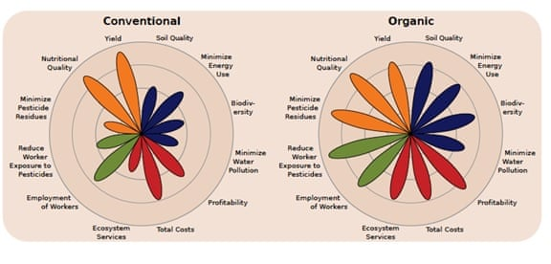

Source: <https://www.theguardian.com/sustainable-business/2016/aug/14/organic-farming-agriculture-world-hunger>

Additional reading: <https://www.ripublication.com/ijafst_spl/ijafstv4n2spl_03.pdf>

Task 1: (10 marks)

1. What are the practices of sustainable agriculture?
2. Can organic farming sustain Indian agriculture?
3. What is organic farming or eco friendly farming?
4. How were ancient agricultural methods eco friendly?
5. List the eco-friendly approaches for farming system.

Task 2:

Make a group presentation on traditional Eco agricultural methods which is followed in your state. (10 marks)

**Session 3**

**SLO 1&2**

History tells us that both floods and droughts were regular occurrence in ancient India. Perhaps this is why every region in the country has its own traditional water harvesting techniques that reflect the geographical peculiarities and cultural uniqueness of the regions. The basic concept underlying all these techniques is that rain should be harvested whenever and wherever it falls.

Archaeological evidence shows that the practice of water conservation is deep rooted in the science of ancient India. Excavations show that the cities of the Indus Valley Civilisation had excellent systems of water harvesting and drainage. The settlement of Dholavira, laid out on a slope between two storm water channels, is a great example of water engineering. Chanakya’s *Arthashashtra*mentions irrigation using water harvesting systems. Sringaverapura, near Allahabad, had a sophisticated water harvesting system that used the natural slope of the land to store the floodwaters of the river Ganga. Chola King Karikala built the Grand Anicut or Kallanai across the river Cauvery to divert water for irrigation (it is still functional) while King Bhoja of Bhopal built the largest artificial lake in India.

Drawing upon centuries of experience, Indians continued to build structures to catch, hold and store monsoon rainwater for the dry seasons to come. These traditional techniques, though less popular today, are still in use and efficient. Here is a brief account of the unique water conservation systems prevalent in India and the communities who have practised them for decades before the debate on climate change even existed.

Source: <https://www.thebetterindia.com/61757/traditional-water-conservation-systems-india/>

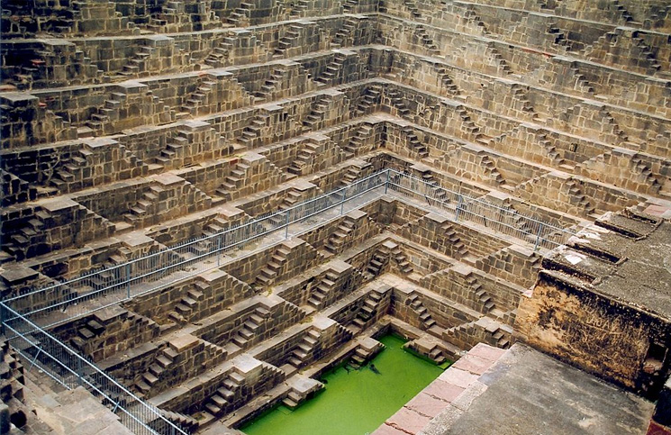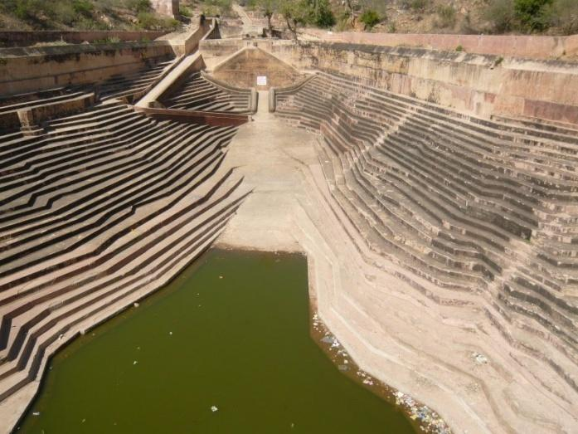

Jhalaras, 1660 AD, Jodhpur Baori, 14th century Rajasthan

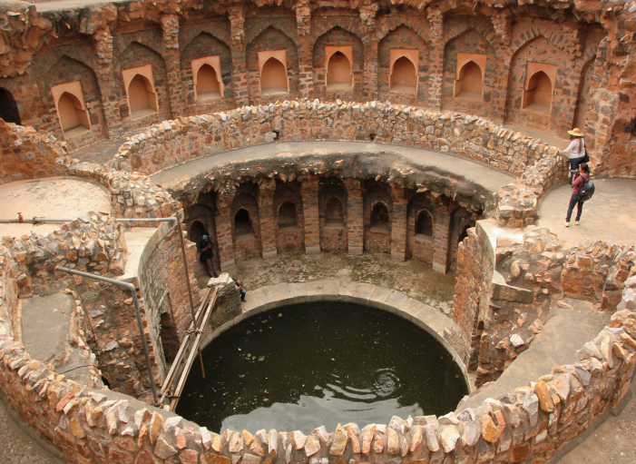 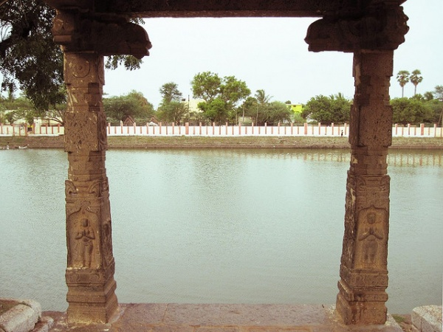

Baoli, 1321 AD, Rajasthan Eri or Tank, 1000 years ago, Tamilnadu

Task 1: (10 marks)

1. What are important water resources of India?
2. List the early water storage methods in your state.
3. Where does India's water come from?
4. What is an aquifer?
5. Write a note on the irrigation methods in India.

Task 2: (10 marks)

Go through this website <http://cgwb.gov.in/AQM/> and identify and write down the aquifer systems of your state. (150 words)

**Module 2**

**Mathematics & Astronomy**

**Session 1**

**SLO 1 & 2**

Time in Hindu mythology is conceived as a wheel turning through vast cycles of creation and destruction (pralaya), known as kalpa. According to the Hindu theory of creation, time (Sanskrit *‘kal’*) is a manifestation of God. Creation begins when God makes his energies active and ends when he withdraws all his energies into a state of inactivity. God is timeless, for time is relative and ceases to exist in the Absolute. The past, the present and the future coexist in him simultaneously.

 In fact the same phenomena of Astrophysics were even known to our ancient sages, the Puranakaras long back in the Puranic age, about 5,000 years ago. They were not only aware of space journeys, but also of the existence of other planets besides the earth which they knew as Pitriloka, Devaloka, Indraloka, Brahmaloka, so on and so forth. Not only this but, they also freely moved from earth to other far-off planets like Brahma loka which had different time speeds than Earth. They were also equipped with knowledge such as that gravity can bend time in space.

Source: <https://www.dailypioneer.com/2017/sunday-edition/space-journeys-in-ancient-india.html>

Additional reading: <https://cds.cern.ch/record/381232/files/9903010.pdf>

<http://www.vkmaheshwari.com/WP/?p=2507>

Task 1:

1. List the two philosophical systems at the basis of Indian physics—and metaphysics
2. What is Vedic Cosmology?
3. Which is the oldest accurate book in the field of astronomy?
4. Discuss how the beliefs of Hinduism are associated with time.
5. What is Puranic Cosmology?
6. The day on which the Sun’s direct rays cross the celestial equator is called
7. The ecliptic
8. The quionox
9. Easter
10. The solstice
11. Which of these objects is the farthest from the Sun?
12. Saturn
13. Neptune
14. Mercury
15. Jupiter
16. The planet which completes one revolution in 88 days around the Sun is:
17. Saturn
18. Mars
19. Mercury
20. Venus
21. The smallest planet of the solar system:
22. Saturn
23. Jupiter
24. Neptune
25. Uranus
26. The small groups of planetary pieces which are confined and revolving between Mars and Jupiter are called:
27. Meteors
28. Comet
29. Celestial bodies
30. Asteroids

Task 2:

Discuss on the topic ‘Time as a coefficient of all consciousness’

**Session 2**

**SLO 1 & 2**

Aryabhata, an Indian Mathematician (c. 500AD) accurately calculated celestial constants like earth's rotation per solar orbit, days per solar orbit, days per lunar orbit. In fact, no source from prior to the 18th century had more accurate results on the values of these constants. Aryabhata's 499 AD computation of pi as 3.1416 (real value 3.1415926...) and the length of a solar year as 365.358 days were also extremely accurate by the standards of the next thousand years.

The notion of time spans that are truly gigantic by modern standards are rarely found in ancient civilizations as the notion of large number is rare commodity. Apart from the peoples of the Mayan civilization, the ancient Hindus appear to be the only people who even thought beyond a few thousand years.

In the famous book *Cosmos*, physicist-astronomer-teacher Carl Sagan writes *"... The dates on Mayan inscriptions also range deep into the past and occasionally far into the future. One inscription refers to a time more than a million years ago and another perhaps refers to events of 400 million years ago, ... The events memorialized may be mythical, but the time scales are pridigious".*

Hindu scriptures refer to time scales that vary from ordinary earth day and night to the day and night of the *Brahma* that are a few billion earth years long. Sagan continues, *"A millennium before Europeans were wiling to divest themselves of the Biblical idea that the world was a few thousand years old, the Mayans were thinking of millions and the Hindus billions"*.

Source: <https://www.cerc.utexas.edu/~jay/anc.html>

A Mathematician named Pingala (c. 100BC) developed a system of binary enumeration convertible to decimal numerals [See 3]. He described the system in his book called *Chandahshaastra*. The system he described is quite similar to that of Leibnitz, who was born in the 17th century.

Invention of Zero: ([Zero invented by Indian Mathematicians (youtube)](https://www.youtube.com/watch?v=pElvQdcaGXE))  
Although ancient Babylonians were known to have used what is often called "place holders" to distinguish between numbers like 809 and 89, they were nothing more than blank spaces or at times two wedge shapes like ". More importantly, they lacked the realization that zero has a place in the number system as well as it comes with a baggage of abstract interpretations. Hence, while they can be credited with intelligently solving a practical problem of avoiding misinterpreting two numbers like 809 and 89, they can hardly be credited with the invention of the complex notion of zero and the even more complex notion of the abstract idea of "nothingness".

Task 1:

1. Give the list of Indian mathematicians from Ancient to Modern India with their contribution. (10 marks)
2. Tabulate the contributions made by Astronomers and Mathematicians
3. Who was the famous astronomer of ancient India?
4. Who was the great mathematician of India?
5. Who is the father of Indian astronomy?

Task 2:

Make a PPT on the topic ‘The idea of life-cycles of the universe’ and submit to your teacher. (10 marks)

**Session 3**

**SLO 1 & 2**

Watch this video <https://www.youtube.com/watch?v=Ge7I_dHL3Z0> and try to answer the questions given below.

Task 1:

How is your birth chart determined? If you have one draw it here.

What do planets represent in Vedic astrology?

How many planets are in Vedic astrology?

[Task 2:](https://www.newyorker.com/magazine/2019/10/28/astrology-in-the-age-of-uncertainty)

[Write notes the topic ‘Astrology in the Age of Uncertainty’ (keeping in mind the pandemic situation)](https://www.newyorker.com/magazine/2019/10/28/astrology-in-the-age-of-uncertainty)

Additional reading: <https://www.refinery29.com/en-us/2016/11/129929/birth-chart-analysis-natal-astrology-reading>

<https://www.youtube.com/watch?v=ihieO3VdyWQ>

**Module 3**

**Session 1**

**SLO 1 & 2**

It is a well-known fact that Traditional Systems of medicines always played important role in meeting the global health care needs. They are continuing to do so at present and shall play major role in future also. The system of medicines which are considered to be Indian in origin or the systems of medicine, which have come to India from outside and got assimilated in to Indian culture are known as Indian Systems of Medicine ([Prasad, 2002](https://www.ncbi.nlm.nih.gov/pmc/articles/PMC2816487/#R54)). India has the unique distinction of having six recognized systems of medicine in this category. They are-Ayurveda, Siddha, Unani and Yoga, Naturopathy and Homoeopathy. Though Homoeopathy came to India in 18th Century, it completely assimilated in to the Indian culture and got enriched like any other traditional system hence it is considered as part of Indian Systems of Medicine ([Prasad, 2002](https://www.ncbi.nlm.nih.gov/pmc/articles/PMC2816487/#R54)). Apart from these systems- there are large number of healers in the folklore stream who have not been organized under any category. In the present review, attempt would be made to provide brief profile of three systems to familiarize the readers about them so as to facilitate acquisition of further information.

Source: <https://www.ncbi.nlm.nih.gov/pmc/articles/PMC2816487/>

Task 1:

Compare and Contrast of the methodologies, popular beliefs, myths and truths about medications. Submit a write up for 150 words. (5 marks)

Task 2:

Discuss the role of Siddha medicine in curing Covid 19

Additional reading: <https://www.ncbi.nlm.nih.gov/pmc/articles/PMC2816487/>

**Session 2**

**SLO 1 & 2**

Holistic therapy is a type of therapy that address the “whole” person. This kind of therapy integrates spiritual, physical, mental, and emotional forms of well-being. Its goal is to help individuals develop a deeper understanding of themselves on *all* these levels. It uses evidence-based treatment and a holistic framework and is often tailored to the individual’s unique needs.

Task 1:

1. What happens in a typical holistic therapy session (5 Marks)
2. What to look for in a holistic therapist (5 Marks)
3. What is nature therapy?
4. Bring out the differences between "*holistic* medicine, alternative medicine and complementary medicine"

Task 2:

Take up a case study, (you can either use the link given below or find a new one for yourself) understand the rationale behind selected sample treatments provided or advised, and give a write up for 150 words) Link for case study: <https://ivcjournal.com/holistic-approach-case-studies/>

**Session 3**

**SLO 1 & 2**

Yoga  is a group of [physical](https://en.wikipedia.org/wiki/Human_body), [mental](https://en.wikipedia.org/wiki/Mind), and [spiritual](https://en.wikipedia.org/wiki/Soul) practices or disciplines which originated in [ancient India](https://en.wikipedia.org/wiki/Ancient_India). Yoga is one of the six [Āstika](https://en.wikipedia.org/wiki/%C4%80stika_and_n%C4%81stika) (orthodox) schools of [Hindu philosophical traditions](https://en.wikipedia.org/wiki/Hindu_philosophy)

There is a broad variety of yoga schools, practices, and goals in [Hinduism](https://en.wikipedia.org/wiki/Hinduism), [Buddhism](https://en.wikipedia.org/wiki/Buddhism), and [Jainism](https://en.wikipedia.org/wiki/Jainism). The term "Yoga" in the Western world often denotes a modern form of [hatha yoga](https://en.wikipedia.org/wiki/Hatha_yoga) and [yoga as exercise](https://en.wikipedia.org/wiki/Yoga_as_exercise), consisting largely of the postures or [asanas](https://en.wikipedia.org/wiki/Asana).

The practice of yoga has been thought to date back to pre-[vedic](https://en.wikipedia.org/wiki/Vedic_period) [Indian](https://en.wikipedia.org/wiki/India) traditions; possibly in the [Indus valley civilization](https://en.wikipedia.org/wiki/Indus_valley_civilization) around 3000 BCE. Yoga is mentioned in the [Rigveda](https://en.wikipedia.org/wiki/Rigveda), and also referenced in the [Upanishads](https://en.wikipedia.org/wiki/Upanishads).  Although, yoga most likely developed as a systematic study around the 5th and 6th centuries BCE, in ancient India's [ascetic](https://en.wikipedia.org/wiki/Sannyasa) and [Śramaṇa](https://en.wikipedia.org/wiki/%C5%9Arama%E1%B9%87a) movements. The chronology of earliest texts describing yoga-practices is unclear, varyingly credited to [the Upanishads](https://en.wikipedia.org/wiki/Upanishads). The [*Yoga Sutras of Patanjali*](https://en.wikipedia.org/wiki/Yoga_Sutras_of_Patanjali) date from the 2nd century BCE, and gained prominence in the west in the 20th century after being first introduced by [Swami Vivekananda](https://en.wikipedia.org/wiki/Swami_Vivekananda). Hatha yoga texts began to emerge sometime between the 9th and 11th century with origins in [tantra](https://en.wikipedia.org/wiki/Tantra).

Yoga gurus from India later introduced yoga to the West, following the success of Swami Vivekananda in the late 19th and early 20th century with his adaptation of yoga tradition, excluding asanas. Outside India, it has developed into [a posture-based physical fitness, stress-relief and relaxation technique](https://en.wikipedia.org/wiki/Yoga_as_exercise). Yoga in Indian traditions, however, is more than physical exercise; it has a meditative and spiritual core. One of the six major orthodox schools of Hinduism is also called [Yoga](https://en.wikipedia.org/wiki/Yoga_(philosophy)), which has its own epistemology, ontology and metaphysics, and is closely related to Hindu [Samkhya](https://en.wikipedia.org/wiki/Samkhya) philosophy.

Source: <https://en.wikipedia.org/wiki/Yoga>

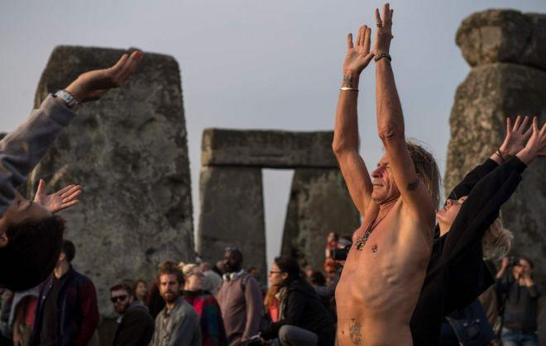

Swami Vivekenanda is seen as the man who brought yoga to the West. The monk from Calcutta travelled to the Parliament of Religions in Chicago in 1894 and spoke about India and Hinduism, before embarking on an influential lecture tour of the United States.

His book Raja Yoga was written in Manhattan in 1896 and had a major impact on Western understandings of what yoga was. Over the coming decades more teachers and disciples of Indian gurus would travel to Europe and America.

Later, in the 1960s, travellers on the hippie trail ended up in Indian ashrams, and images of The Beatles visiting the Maharishi Mahesh Yogi in Rishikesh in 1968 drew greater international attention towards Indian spiritualism and, of course, yoga.

Source: <https://www.bbc.com/news/world-40354525>

Task 1:

1. Why is International Yoga Day celebrated? (5 Marks)
2. [How is yoga different from meditation?](https://www.emedicinehealth.com/yoga_faqs/article_em.htm#how_is_yoga_different_from_meditation) (5 Marks)
3. Who is believed to be the father of Yoga?
4. Krishnamacharya
5. Gautam Buddha
6. Maharshi Patanjali
7. Adi Shankaracharya

4 . Yoga has eight components, also known as the eight fold path of life — Niyama, Asana, Pranayama, Dhyana, Samadhi are five of them. Which are the other three?

1. Savichar, Santosa, Tapas
2. Asteya, Aparigraha, Brahmacharya
3. Ananda, Asmita, Aachaar
4. Yama, Dharana, Pratyahara

5. The word “Yoga” comes for Sanskrit. What is the literal meaning of this word?

1. Hindu system of philosophy & meditation
2. Inner peace & tranquility
3. Joining together
4. Controlled breathing

6. Over time, many new postures have been added to the original compendium of Asanas that yoga started with to incorporate modern day fitness requirements. How many classic Asanas were enlisted in the initial texts?

1. 84
2. 108
3. 33
4. 195

7. Surya Namaskar is considered to be a complete exercise for the body and has often been cited as a combination of Asanas that helps in stretching almost all the major muscles. How many different Asanas does Surya Namaskar comprise of?

1. 12
2. 7
3. 10
4. 8

8. Yoga has many practitioners in the West and several Hollywood celebrities such as Adam Levine and Julia Roberts have endorsed it. Indra Devi is credited with introducing Yoga to the West. Which country did she belong to?

1. Nepal
2. Russian
3. India
4. USA

9. An Indian youth organisation entered the Limca Book of Records for simultaneously performing Yoga for the longest duration. Which organisation was this?

1. NSS
2. LTS
3. NSS
4. Girl Scouts

10. In the popular TV series *Friends*, one of the main characters is seen talking to Mr. Treeger, the superintendent of Monica’s building, about attending Yoga classes. Which character is this?

1. Ross
2. Phoebe
3. Monica
4. Mike

Source: <https://www.outlookindia.com/quiz/story/the-yoga-quiz/79>

**Module 4**

**Session 1**

**SLO 1 & 2**

The architecture of [India](https://en.wikipedia.org/wiki/India) is rooted in its [history](https://en.wikipedia.org/wiki/History_of_India), [culture](https://en.wikipedia.org/wiki/Culture_of_India) and [religion](https://en.wikipedia.org/wiki/Indian_religions). Among a number of architectural styles and traditions, the contrasting [Hindu temple architecture](https://en.wikipedia.org/wiki/Hindu_temple_architecture) and [Indo-Islamic architecture](https://en.wikipedia.org/wiki/Indo-Islamic_architecture) are the best known historical styles. Both of these, but especially the former, have a number of regional styles within them. An early example of town planning was the Harappan architecture of the Indus Valley Civilisation. People lived in cities with baked brick houses, streets in a grid layout, elaborate drainage systems, water supply systems, granaries, citadels, and clusters of large non-residential buildings. Much other early Indian architecture was in wood, which has not survived.

Hindu temple architecture is mainly divided into [Dravidian](https://en.wikipedia.org/wiki/Dravidian_architecture) and [Nagara](https://en.wikipedia.org/wiki/Nagara_architecture) styles. Dravidian architecture flourished during the rule of the Rashtrakuta, Hoysala, [Chola](https://en.wikipedia.org/wiki/Chola), [Chera](https://en.wikipedia.org/wiki/Chera), and [Pandyan](https://en.wikipedia.org/wiki/Pandyan) empires, as well as the [Vijayanagara Empire](https://en.wikipedia.org/wiki/Vijayanagara_Empire).

Source: <https://en.wikipedia.org/wiki/Architecture_of_India>

A glimpse of ancient Indian architect

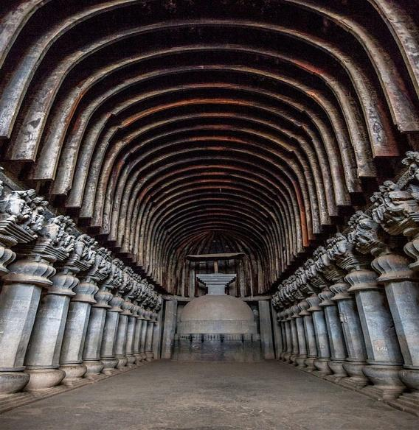 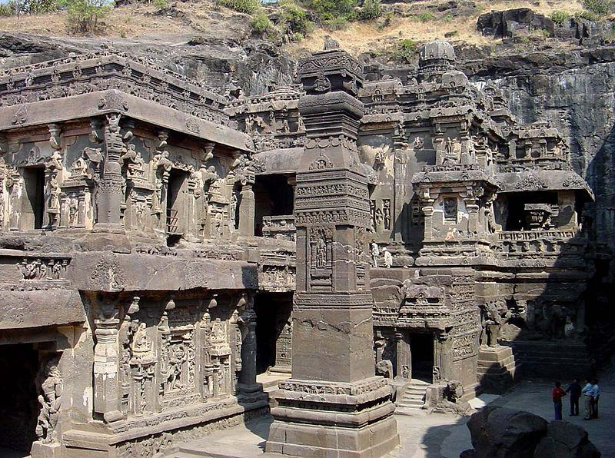 Buddhist [Karla Caves](https://en.wikipedia.org/wiki/Karla_Caves), Maharashtra [Kailasa temple, Ellora](https://en.wikipedia.org/wiki/Kailasa_temple,_Ellora)

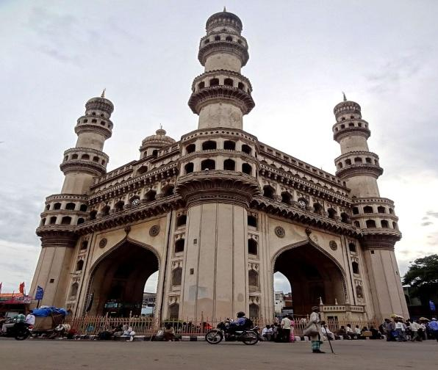 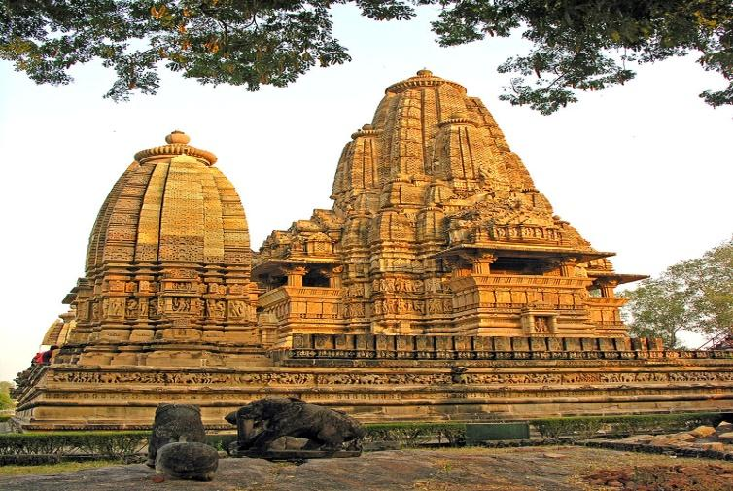

Charminar, Hyderabad[Lakshmana Temple, Khajuraho](https://en.wikipedia.org/wiki/Lakshmana_Temple,_Khajuraho)

Task 1:

Collect pictures about the ancient town planning system in India. Paste them in the A4 sheets

Discuss on how the ancient monuments are preserved and protected in our country. (10 marks)

Task 2: Collect pictures of buildings and paintings which were prevalent during the  [Classical period (320 BCE–550 CE)](https://en.wikipedia.org/wiki/Ancient_Indian_architecture#Classical_period_(320_BCE%E2%80%93550_CE)) (10 marks)

Task 3:

Match the following:

| 1.Nalanda University | Gupta Dynasty | Puri, Odisha |
| --- | --- | --- |
| 2.The seven Pagodas of Mahabalipuram | Narasimhavarman II | Chhatarpur, Madhya Pradesh |
| 3.Jagannatha Temple | King Anantavarman Chodaganga Deva (Eastern Ganga Dynasty) | Rajgir, Nalanda (Bihar) |
| 4.Lingaraj Temple | Somavamsi Dynasty | Agra, Uttar Pradesh |
| 5.Khajuraho Group of Monuments | Chandela Dynasty | Mahabalipuram (Tamil Nadu) |
| 6.Brihadeeswara Temple (also known as RajaRajeswara Temple) | Raja Raja Chola I | Hanamakonda, Telangana |
| 7.Ajanta Caves | Satavahana Dynasty later Mauryan Dynasty | Agra, Uttar Pradesh |
| 8.Ellora Caves | Kalachuri, Chalukya, and Rashtrakuta Dynasties | Delhi |
| 9.Agra Fort | Mughal Emperor Akbar | Bhubaneswar, Odhisha |
| 10.Thousand Pillars Temple | Kakatiya Dynasty | Thanjavur, Tamil Nadu |
| 11.Red Fort | Mughal Emperor Shah Jahan | Aurangabad, Maharashtra |
| 12.Taj Mahal | Mughal Emperor Shah Jahan | Aurangabad, Maharashtra |
| 13.Konark Sun Temple | Narasimhadeva I (Eastern Ganga Dynasty) | Konark, Odisha |

Source: <https://www.tutorialspoint.com/general_knowledge/general_knowledge_historical_monuments_of_india.htm>

**Session 2**

**SLO 1 & 2**

The history of metallurgy in the Indian subcontinent began prior to the 3rd millennium BCE and continued well into the [British Raj](https://en.wikipedia.org/wiki/British_Raj). [Metals](https://en.wikipedia.org/wiki/Metal) and related concepts were mentioned in various early [Vedic age](https://en.wikipedia.org/wiki/Vedic_age) texts. The [Rigveda](https://en.wikipedia.org/wiki/Rigveda) already uses the [Sanskrit](https://en.wikipedia.org/wiki/Sanskrit) term Ayas (metal). The [Indian](https://en.wikipedia.org/wiki/History_of_India) cultural and commercial contacts with the [Near East](https://en.wikipedia.org/wiki/Near_East) and the [Greco-Roman world](https://en.wikipedia.org/wiki/Greco-Roman_world) enabled an exchange of metallurgic sciences. With the advent of the Mughals, India's [Mughal Empire](https://en.wikipedia.org/wiki/Mughal_Empire) (established: April 21, 1526—ended: September 21, 1857) further improved the established tradition of metallurgy and metal working in India.

The imperial policies of the [British Raj](https://en.wikipedia.org/wiki/British_Raj) led to stagnation of metallurgy in India as the British regulated mining and metallurgy—used in India previously by its rulers to build armies and resist [England](https://en.wikipedia.org/wiki/England) during various wars.

A glimpse of traditional metal carvings

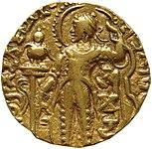 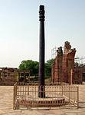

Coin of [Samudragupta](https://en.wikipedia.org/wiki/Samudragupta) (c. 350—375). [The iron pillar of Delhi](https://en.wikipedia.org/wiki/Iron_pillar_of_Delhi) (375—413).

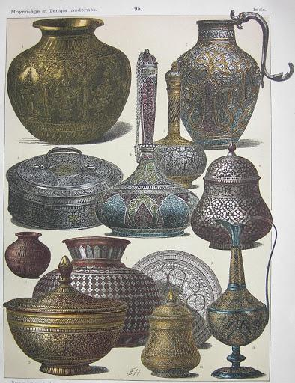 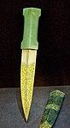

  Metal vessels Dagger and its scabbard

Source: <https://en.wikipedia.org/wiki/History_of_metallurgy_in_the_Indian_subcontinent>

Task 1:

1. What do you mean by metallurgy?
2. What were the various metals used in ancient India?
3. Collect pictures of Bronze Age sculptures and identify its uniqueness. (10 Marks)

**Session 3**

**SLO 1 & 2**

Textiles are an important source of reference for the cultural studies because of their universality. Textiles have always draped the body, whether human/deities/animal, floor and furniture. Unlike stone, clay, metal etc. textiles were traditionally made from biodegradable materials. Cotton (natural cellulose fiber), silk, wool (natural protein fibers) were three main materials for textiles, apart from bast and leaf fibers. Initially very simple technologies were used for making the textiles. The most basic skill involved spinning the fiber into yarn and then change it to fabric by a process called weaving. The implements used for weaving and spinning were and in many parts of India still continue to be of biodegradable materials like wood .There is exist a very scant reference of the fabric making skills in the archaeological excavations. Along with the tools of their manufacture, fabric materials have long degraded in our tropical climate. Scholars like Sir John Marshall while talking of the Indus valley culture have dealt with existence of textile industry , which they opined was restricted at this period to India and was not extended to western world until 2000 years later ( Marshal 1984). The terracotta figurines, minute fabric scraps found adhering to the sides of the silver vase (Marshal,1973), the tools and equipment used for manufacture of textiles out of these materials were mainly made of biodegradable materials. Very fragile nature of textiles therefore restricts the rebuilding of the textiles manufacture technology on the basis of the archaeological materials alone. When we look through the archaeological excavations in Indian continent, we find that majority of the archaeological sites in all parts of the continent have produced spindles made of terracotta; these provide direct evidence of presence of spinning and weaving technology in these periods. The Harappans invented the needle with the eye at the pointed end (as is used in sewing machines). This type of needle was reinvented in Europe during Roman times. Apart from this, any evidence of terracotta vessels used for dyeing, washing etc. may also provide useful linkages to study the earlier textile related technologies.

Source: <https://www.infinityfoundation.com/mandala/t_pr/t_pr_gupta_textile_frameset.htm>

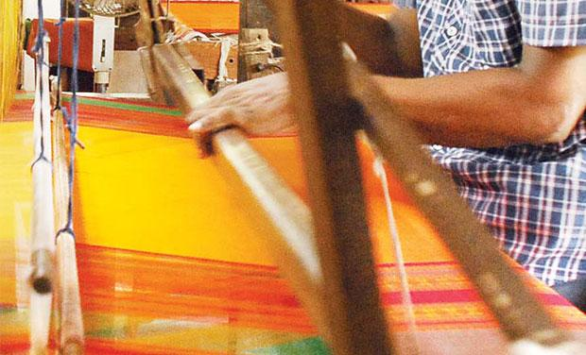 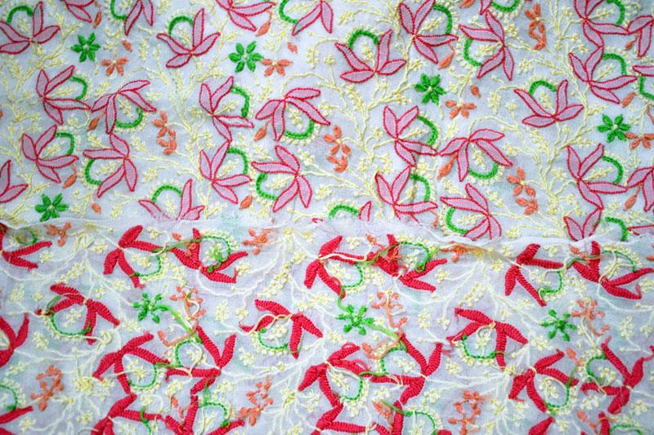

Silk, Tamilnadu Chinkari, Lucknow



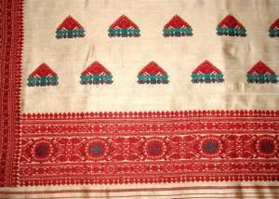 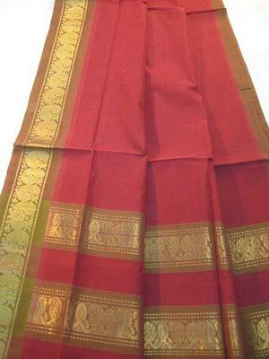

Muga silk, Assam Mangalagiri, Andhra Pradesh

Task 1:

1. Which fabric is famous in West Bengal?
2. What types of fabrics are popular in India?

3. Which of the traditional textile motif is related to the French naut open work and Herringbone stitch techniques?

A. Chikankari of Lucknow

B. Kantha of West Bengal

C. Pipli Applique Work

D. Rajasthani Embroidery

4. Which of the traditional textile motif is the basically means ‘throat’, is associated with Lord Shiva?

A. Chikankari of Lucknow

B. Kantha of West Bengal

C. Pipli Applique Work

D. Rajasthani Embroidery

5.  Which of the following traditional textile motif is named after the village?

A. Chikankari of Lucknow

B. Kantha of West Bengal

C. Pipli Applique Work

D. Rajasthani Embroidery

6. Which of the following traditional textile motif is closely related to the embroidery art form of Gujarat and Sindh?

A. Chikankari of Lucknow

B. Kantha of West Bengal

C. Pipli Applique Work

D. Rajasthani Embroidery

7. Which of the following is very popular art form of Himachal Pradesh?

A. Chamba Handkerchief

B. Banni and Heer Bharat

C. Kutch and Kathiawar Embroidery

D. Bagh Kashidakari

8. Which of the following is signature art form of tribal community of Gujarat?

A. Chamba Handkerchief

B. Banni and Heer Bharat

C. Kutch and Kathiawar Embroidery

D. Bagh Kashidakari

9. Which of the following is famous art form of Punjab region?

A. Chamba Handkerchief

B. Banni and Heer Bharat

C. Kutch and Kathiawar Embroidery

D. Bagh Kashidakari

10. Which of the following is the correct definition of the ‘Motif’?

A. It refers to creative activity, such as painting, music, literature, and dance.

B. It refers to a design or figure that consists of recurring shapes or colours, as in architecture or decoration.

C. It is visual art form such as painting or sculpture, producing works to be appreciated primarily for their beauty or emotional power.

D. None of the above

Source: <https://www.jagranjosh.com/general-knowledge/gk-questions-and-answers-on-the-traditional-textile-motifs-of-india-1554878966-1>

Task 2:

Compare the Temple Architecture of North and Southern Indian States. Make a collage on the same and submit. (10 marks)

**Module 5**

**Session 1**

**SLO 1 & 2**

Unity in Diversity: India is a land of unity in diversity where people of different sects, caste and religion live together. India is also called the land of unity in diversity as different groups of people co-operate with each other to live in a single society. Unity in diversity has also become strength of India.

Secularism: The word secularism means equality, impartiality, etc. towards all religion. India is a secular country, which means, equal treatment of all the religions present in India.

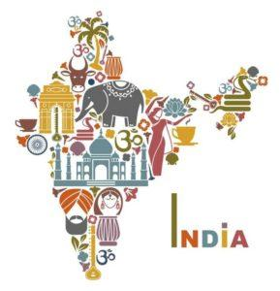

India is birth place of four major religions, such as, Hinduism, Sikhism, Jainism and Buddhism.  
Other religions exist as minorities here, including Abrahamic religions.  
India is called a land of diversity, i.e., people belonging to almost every faith can be found in India. Many religions coexist in India such as Hinduism, Sikhism, Jainism, Buddhism, Islam, Christianity, Zoroastrians, Judaism and many more. People of all religions live together with great peace.

Source: <http://trebeki.info/en/the-indian-culture-traditions-religions-festivals-music-dance-clothing-food-movies/>

Task 1:

1. What are the customs followed in India?
2. What are the cultural practices followed in your family to conduct a grand wedding? What are the religious practices followed in your family when an infant is born? Analyse these two situations and identify the uniqueness of your culture and religious practices. (10 Marks)
3. List 10 idioms or proverbs in your mother tongue that are connected to seasons and festivals.

**Session 2**

**SLO 1 & 2**

India is known as a cultural and foodie country and this is nothing that we did not know about. We Indians are proud foodies and equally, love to have someone gladly dive into our enormous world of varied cuisines. There are 29 states in India, and each of them has more than just one famous dish when it comes to food. There is a wide range of cuisine in the nation which pampers the taste buds and impresses everyone. No matter in which state you are, you will surely love the regional cuisine. Indian food is generally known for its spiciness and every single spice used in Indian dishes carries some or the other nutritional as well as medical properties which not only makes it unique in taste but also very healthy.

A peep into delicacies of a few states in India.

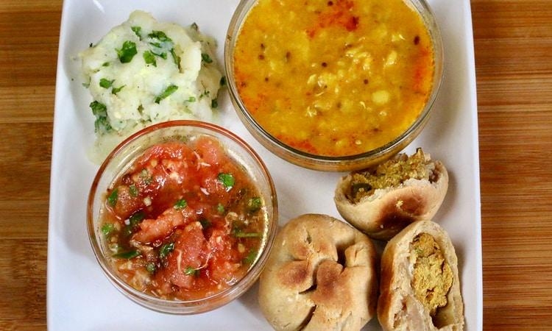 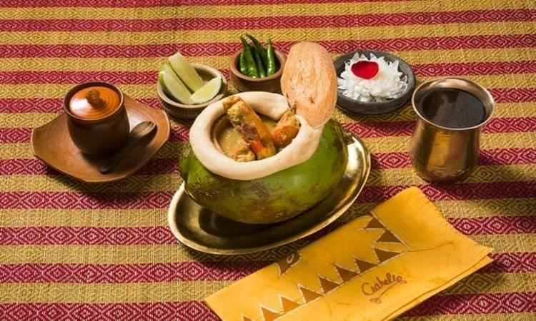

Bihar Kolkata

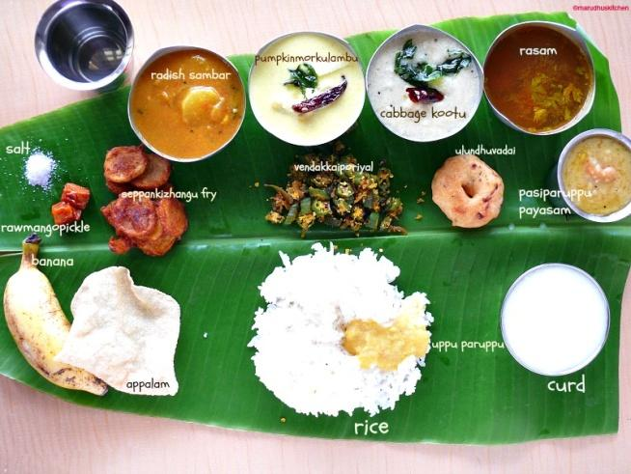 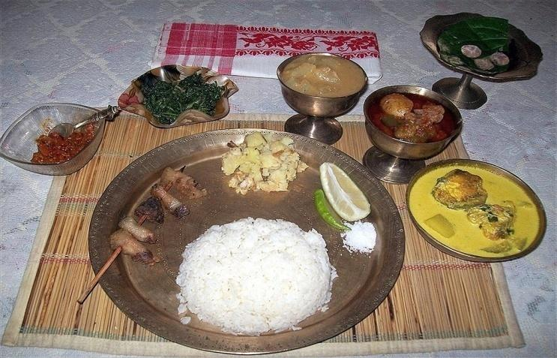

Tamilnadu Assam

Task 1:

Let Your Food Be Your Medicine – Justify this statement in accordance to the food you had during the pandemic.

Task 2:

Collect a few old sayings related to food habits and make a collage (10 Marks)

**Session 3**

**SLO 1 & 2**

The role of [translation](https://en.wikipedia.org/wiki/Translation) can hardly be over-emphasised in a multilingual country like India with 22 languages recognised in the eighth schedule of the constitution, 15 different scripts, hundreds of mother-tongues and thousands of dialects. One can very well say that India’s is a translating consciousness and the very circumstances of their real existence and the conditions of their every day communication have turned Indians bilingual if not multilingual. One can even add without exaggeration that India would not have been a nation without translation and we keep translating almost unconsciously from our mother-tongues when we converse with people who use a language different from ours.

Source: <https://digitallearning.eletsonline.com/2011/03/translation-its-role-and-scope-in-india/>

Task 1: Identify ten traditional sayings/proverbs, related to hygiene and practices, in your mother tongue and translate them. (10 Marks)

Task 2: Translate the regional sayings (any 10) which are used in your locality and discus the problems you faced during the process of translation.